www.leap-re.eu contact@leap-re.eu @leapRE_EU

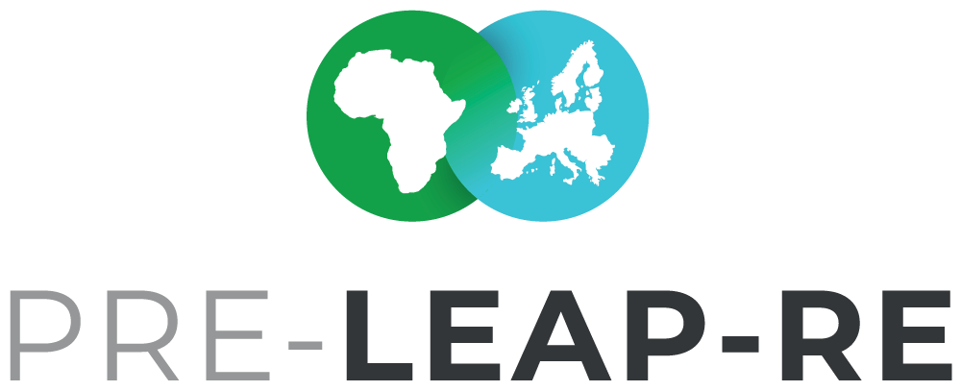Long-Term Perspective
BACKGROUND PAPER #3
Draft Version 6
21 May 2019

The Background Papers are documents in progress, which will form the basis for the discussion with committed stakeholders, who want to contribute to the joint programme LEAP-RE and who may want to become a consortium member or associated partner. Feedback and suggestions for these documents are welcome. The intention with the Background Papers is to foster an inclusive process as possible. The Background Paper series will be finalized in June/July 2019 after the PRE-LEAP-RE #2 Strategic Workshop from 24-26 June 2019 in Stellenbosch, South Africa.

The current Background Papers:

#1 BP Roadmaps & Ecosystem
Multi-Annual Roadmaps on Research &Innovation and Human & Institutional Capacity Building - Agendas & Pathways | Outcomes from the PRE-LEAP-RE Ecosystem Analysis

#2 BP Funding & Private Sector
Funding Concept | Private Sector Involvement | Open Philosophy & Intellectual Property Rights

#3 BP Long-Term Perspective
Theory of Change and Impact Pathways | Programme and Innovation Management Cycle
| Knowledge Management and Communication Framework | Monitoring & Evaluation Concept

#4 BP Individual Funding & Contribution Regulations
Individual (National) funding regulations will be collected and have to be applied supplementing the general agreed funding regulations of the consortium.

Co-coordinators for this Background Paper
Mr Fadel Traoré | Fadel.Traore@ANER.sn
Mr Stefan A. Haffner | Stefan.Haffner@DLR.de

Team of co-authors
AESG, Rwanda (Africa Energy Services Group Ltd.)
ANER, Sénégal (Agence Nationale pour les Energies Renouvable)
CEA, France (Commissariat à l'énergie atomique et aux énergies alternatives) DLR-PT, Germany (German Aerospace Center – Project Management Agency) DST, South Africa (Department of Science and Technology)
IE, Belgium (KIC Innoenergy SE)
JYU/UNIPID, Finland (University of Jyväskylä / UniPID)
LGI, France (LGI Consulting)
MESRS, Algeria (Ministry of Higher Education and Scientific Research)
SU, Kenya (Strathmore University)

This project has received funding from the European Commission’s Horizon 2020 Research and Innovation Programme. The content in this presentation reflects only the author(s)’s views. The European Commission is not responsible for any use that may be made of the information it contains.

Content

Introduction 3
- Theories of Change and Impact Pathways 4
- Long-Term Network Building and Management of Action 7
- Knowledge Management and Communication Framework 16
- Coordinating Secretariat Concept 18
- Glossary 20

Summary
In this background paper (BP) the elements for a long-term perspective of LEAP-RE has been drafted. This includes explanations about the role Theories of Change and Impact Pathways (TCIP) as an instrument for future planning and Monitoring and Evaluation (M&E) as well as the model of the Programme and Innovation Management Cycle (PIMC) for a long-term learning and collaborative programming and impact process in Research and Innovation (R&I) and Human and Institutional Capacity Building (HICB) in multi-stakeholder ecosystems. Furthermore an AU-EU Knowledge Management and Communication Framework (KMCF) is described towards a more effective and efficient exchange and collaboration between all actors in the field of RE.

Introduction
The strength of joint programming activities in R&I is the coordination of funders and other actors while pooling resources to jointly tackle challenges in research, innovation and capacity building.
One weaknesses of joint programmes in R&I could be the lack of focus because topics often are too broad towards integrating more funders. Since joint programmes are in a historical and a future oriented context, they could built on existing knowledge and networks and hand over results towards future activities in R&I. But, and these are two further weaknesses, funding networks tend to start with research topics that are lacking gaps analysis and also tend to halt their collaboration after the first call. They are mostly neither embedded in a long-term process nor in a long-term vision. Therefore, another weakness is that funding networks do not systematically communicate the research outputs and analysis of outcomes to be fed into innovation systems, which also doesn’t allow a proper impact analysis.
Threats of joint programmes in R&I are about that less focussed research does not sufficiently address local or specific challenges. Dispersed results from research might also be not well understood by end- users or the amount of available research results is too big and only disseminated instead of communicated without analytical reflection in a dialogue with end-users, and therefore research might be not put into use.
The opportunities of joint programmes are research-recommendation uptake if they support building communicating R&I networks which sets up close linkages or even integrates into innovation systems. This would mean involving experienced actors from different disciplines and sectors along value chains, including end-user, into the development process of joint programmes in R&I right from the beginning. This could result in (sub-) regional system oriented agenda setting for research and recommendations based on and addressing real needs. Furthermore condensed and targeted communication of summaries of research outputs and recommendations based on historical knowledge in the field of R&I could lead to an institutionalisation of learning and feed into future R&I programmes. Building a long-term collaboration-network and –infrastructure over and above of single programmes is a further opportunity.
Towards benefiting from the above stated strength and opportunities of joint programmes in R&I and for addressing their weaknesses and threats, they should be embedded in three major elements which should form the basis for long-term inclusive collaborations:

  - Theory of Change and Impact Pathway (TCIP),
  - Long-term model of Programme and Innovation Management Cycles (PIMC)
  - Knowledge Management and Communication Framework (KMCF).

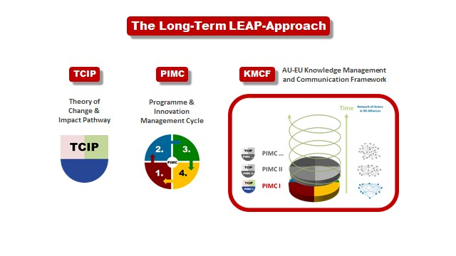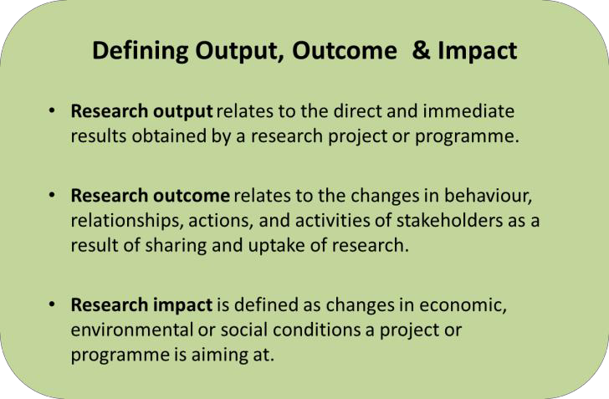Figure 1: The Long-Term LEAP-Approach

- Theories of Change and Impact Pathways
A Theory of Change & Impact Pathway is a starting point for R&I activities and it is a planning and communication tool for reflecting regularly on processes, both on project and programme level.
At the beginning of the development of a programme, all relevant actors who are involved or affected by the programmes’ activities, should be represented and involved in a dialogue for analyzing a specific situation. In this case the situation about RE in Africa and Europe will have to be addressed by defining agendas for Research and Innovation (R&I) and Human and Institutional Capacity Building (HICB), together with preliminary impact pathways about expected output, outcome and impact
of the envisaged activities. In the case of (PRE-) LEAP-RE these agendas and impact pathways are titled as Multi-Annual Roadmaps.
Once the research output of a programme is available, e.g. after LEAP-RE funded projects came to an end and perhaps research results from other ‘external’ research and innovation activities should be merged with the programme’s results, the TCIP will allow a structured way of reflection about the state of affairs in the ‘eco-system’ of actors in RE and the next steps to be taken.
In case a programme comes to an end only with the publication of research output, but no further process for the collaboration between scientists and innovators towards the use of the research results has been established, the value of the TCIP and the research will not have been fully exploited.

After a period of research activities questions occure like: Is the research output sufficient to address the expected outcomes and impact? Are the intentions of the TCIP still in line with the needs in the current situation? Are the expected Multi-Annual Roadmaps still realistic? Which new questions and needs occurred during the research period? About these and other questions, the involved stakeholders could reflect by focusing on their common TCIP towards the implementation of the gained knowledge. Therefore a proper R&I programme should include a process like a kind a ‘follow up’ towards the improvement of the situations that have been intended to be addressed with the research as well as for learning from the whole R&I process.
For fostering research uptake, the programm’s research output might have to be reformatted by a group of experts, and then it would have to be communicated to very different end-users, like e.g. entrepreneurs, decision makers and NGO’s who are working in the field of RE. After a period of time, about which the stakeholders who are involved will agree upon, e.g. three years, the TCIP once again could form the reference point for reflection about the programm’s activities. As a final reflection at the end of a programme, the TCIP could then also serve as a starting point for a new, second programme including a new TCIP#2.
It is important to note, that the TCIP would not only be applied on the programme level, but also in all ‘projects’ funded in the programme’s context. This means that research partners will have to develop with their consortia individual project TCIPs, which will also serve during the projects’ periods as a planning and communication tool.
TCIPs in general are reference points for dialogues in the mid and at the end of different processes.
The development of a TCIP starts with a block of analytical activities, like e.g. the eco-system analysis already conducted by PRE-LEAP-RE (see the figure about the TCIP below).
Which problems have to be addressed? Which causes, in particular knowledge and capacity related causes could be identified? Answers to these questions, together with a context analysis including a stakeholder analysis, will give a clearer picture about the situation to be addressed.
Then, in a project like PRE-LEAP-RE, together with other stakeholders, agendas and impact pathways R&I and HICB activities will have to be developed (see #1BP Roadmaps & Ecosystem). The Multi-Annual Roadmaps are symbolized as 6 red arrows in figure 1 below.

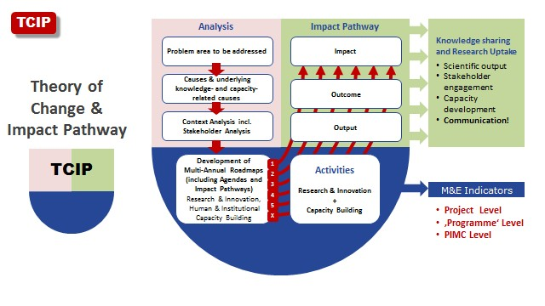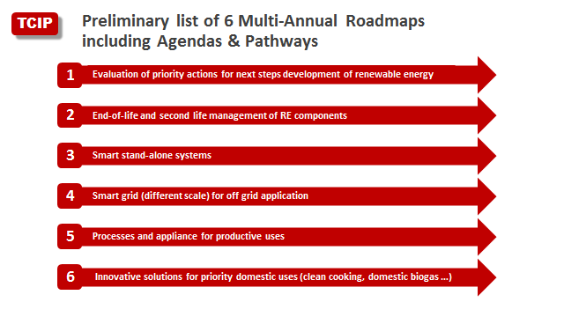Figure 2: Theory of Change and Impact Pathway

Currently the following 6 Multi-Annual Roadmaps for LEAP-RE are in the debate.

Figure 3: Preliminary list of Agendas & Pathways

In reality impact pathways are more complex and not that straight as suggested in the TCIP model. It is intended to paint with a TCIP an ideal image of knowledge sharing and research uptake, including

stakeholder engagement and capacity development, for orientation purposes and as an element towards a long-term collaboration in R&I.
Once a consortium of partners in a programme agreed on the Multi-Annual Roadmaps, a long-term M&E concept could be developed which will serve the coming programm as well as the learning process towards coming programmes.
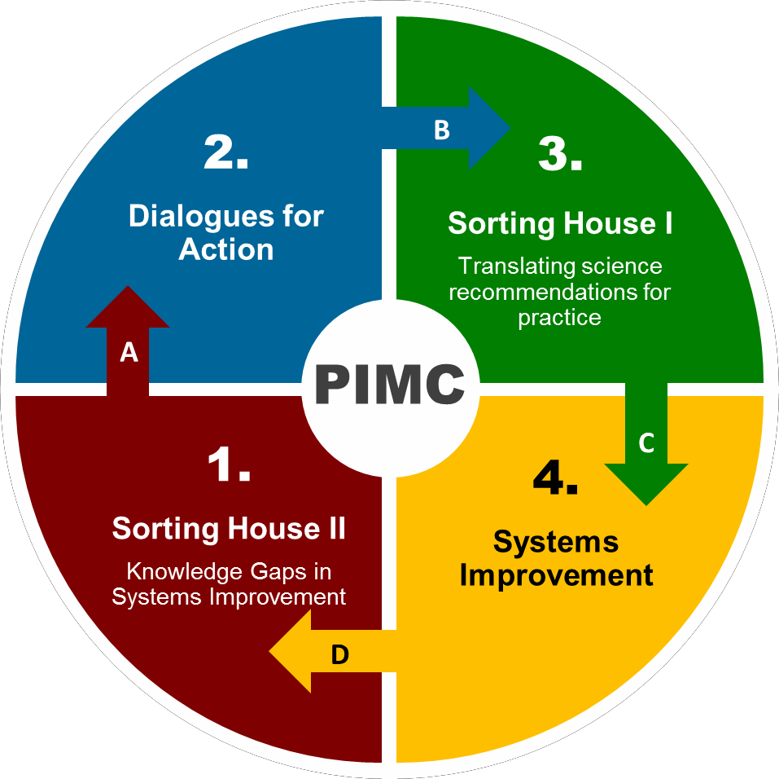How could a bundle of project’s TCIPs in combination with a programme TCIP initiate a process for long- term learning, collaboration and management in R&I networks? For this, as a pilot, the model of a Programme and Innovation Management Cycle (PIMC) is suggested.

Long-Term Network Building and Management of Action

Figure 4: The Programme and Innovation Management Cycle (PIMC)

The PIMC is a new universal model in progress that recently has been developed, together with the AU-EU KMCF approach, in ERA-Net Cofund LEAP-Agri. The PIMC will be applied and developed further as a pilot in LEAP4FNSSA (FNSSA stands for Food and Nutrition Security and Sustainable Agriculture) with the same intention like in LEAP-RE, to initiate and maintain an inclusive network of partners in R&I.
The inclusive PIMC model contributes towards the development of a common understanding of processes which are necessary for network building, agenda setting, effective research uptake towards innovations and the institutionalisation of learning. Furthermore it gives orientation for actors in temporary programmes and long-term strategic cycles like that of funding institutions or the AU-EU HLPD (High Level Policy Dialogue). It describes a joint cycle with actors and activities.
The advantage of this model is, that actors in programmes could share a common theoretical and practical reference point together with other ‘external actors’ in already ongoing activities in the field of RE.

PIMC in LEAP-RE gives orientation for all network partners involved and is the basis for the organisational design and management of LEAP-RE.
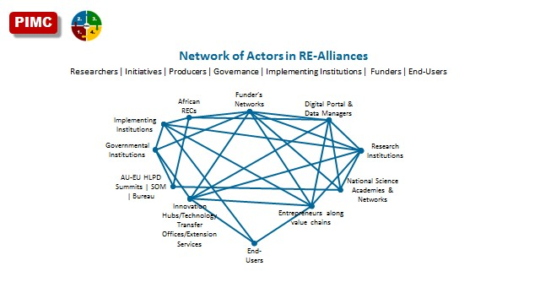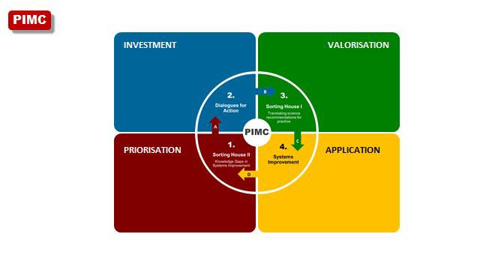Following the quadruple helix approach for including actors from the private sector and civil society, academia and policy makers, the partners in a PIMC are manifold (see figure 5).

Figure 5: Network of Actors in RE-Alliances

A PIMC works clock-wise. The following descriptions are drafting the four segments in a first PIMC (PIMC1) in general. The implementation activities in PRE-LEAP-RE (in Green lettering) and in the coming LEAP-RE (in Blue lettering) and perhaps thereafter will be described also.

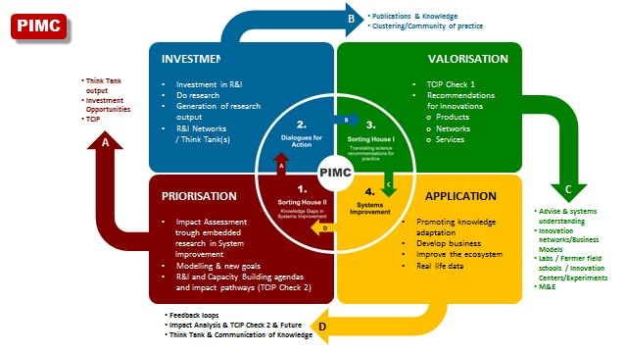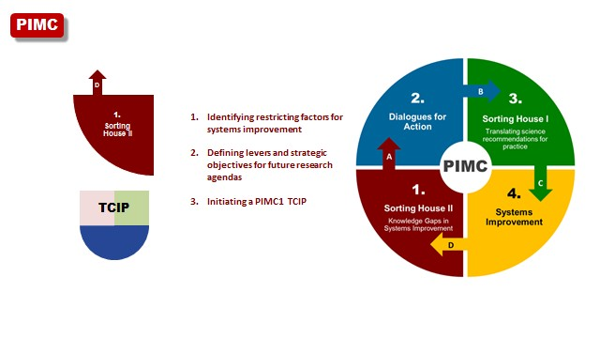Figure 6: Characteristics of the four PIMC segments

Figure 7: Details and levers of the four PIMC segments

- Sorting House II

Figure 6: PIMC Segment 1 | Sorting House II

- Dialogues for Action

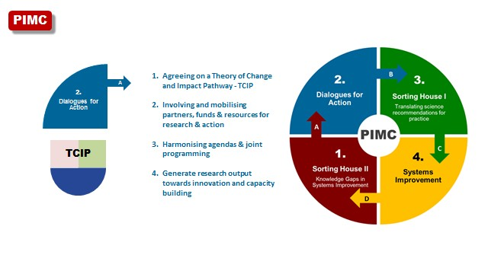Figure 7: PIMC Segment 2 | Dialogues for Action

In the second segment of the PIMC1, ‘Dialogues for Action’ a TCIP for a PIMC will be developed in the frame of dialogues with relevant partners following the quadruple helix approach. Partners, funds and resources for research action will have to be involved and mobilised. In these dialogues different partner’s agendas will have to be harmonised towards a joint programming for implementing research towards innovation. For managing the joint programming one or more secretariats will have to be established. One Coordination Secretariat - CoSe - for managing and coordinating the LEAP-RE network (see #2 BP Funding & Private Sector) and furthermore, if it is not the role of the CoSe to organise calls, specific Call Secretariat(s) - CS – could be considered. It is already intended to develop and maintain a secretariat concept including the digital basis (website, data base and/or linkages to existing data bases) as a long- term infrastructure for the time after the LEAP-RE.
This second segment of the PIMC1 will end with the availability of the research outputs. This might be likely already after 4 years and coincides perhaps also with the end of LEAP-RE. The researchers will have been requested to develop and implement a concept for dissemination and communication of research results in their respective projects. The LEAP-RE consortium will meet to continue with the PIMC 1 in segment 3, whether as a project consortium or already as a project independent network.

✦ PRE-LEAP-RE activities 2018/2019:
- Ecosystem analysis and identification of collaboration opportunities (including the results of the Ecorys study and the work of the African Europe Energy Partnership (AEEP) and in particular in its RECP programme).
- Development, together with potential LEAP-RE partners and associated partners, of
  - TCIP1 for PIMC1
  - PIMC1 Multi-Annual Roadmaps
  - PIMC1 organisation and funding principles will be developed
  - PIMC1 M&E framework and tools (project & programme level) will be developed
  - LEAP-RE knowledge management and communication concept for a LEAP-RE infrastructure

    - Round tables and two workshops with potential LEAP-RE partners (selection of participants will be based on the PRE-LEAP-RE meta-analysis) to develop the RIA and PIMC1
    - Communication with stakeholders via website and other information channels
    - Forming one or more research alliances and one or more interdisciplinary and inter-sectoral alliances to be framed by LEAP-RE (PRE-LEAP-RE will built on existing alliances such as the European Energy Research Alliance – EERA, which is already a consortium partner)
    - Preparations and forming a team for the EJP proposal writing and identification of a coordinator or two co-coordinators (one African and one European) for LEAP-RE

✦ Pre-identified LEAP-RE activities (2020 and following):
- Establishing the TCIP as an instrument for research projects combined with the obligation to develop concrete individual communication methods, technologies and actions plans (validated by end-users) for research uptake in each respective research project as well as for LEAP-RE as a whole.
- Establishment and development of a sustainable model of practical management modules, like a co- coordination team organised in a CoSe, including a communication strategy and modules which shall support Sorting House I and Sorting House II, as well as one or more call secretariat(s), and furthermore different work packages during PIMC 1. This model will serve at the same time as a draft for future PIMCs and a vital RE-network and includes a sustainable funding scheme. The modular character would have to allow changing responsibilities in coming PIMCs, like periodically changing co-coordinators in CoSes.
- Implementation of research activities (along agreed options, e.g. via open calls for proposals addressing also external researchers (=non-LEAP-RE consortium members) and/or research on agreed fields of research with LEAP-RE consortium members and possibly associated partners).
- Forming a group of experts for Sorting House I and Sorting House II and a communication concept for both Sorting Houses.
- Forming a group of experts for Sorting House I (Segment 3 of the PIMC1) and Sorting House II (Segment 1 of the PIMC) and designing a communication concept (including knowledge management and communication methods and technologies) for the system improvement (the activities in segment 4 of the PIMC1).
- Forming a group of existing data base managers for linking already existing data bases in the field of RE

Sorting House I | Translating science recommendations for practice

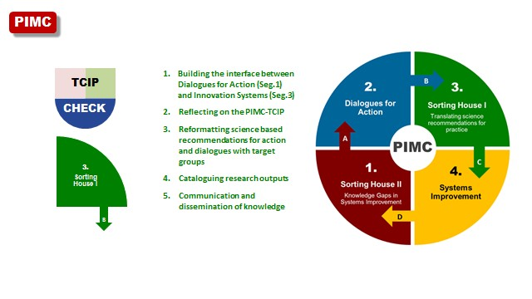Figure 8: PIMC Segment 3 | Sorting House I

Sorting House I is the third segment of the PIMC1 and forms the interface between
Dialogues for Action (segment 2) and the activities in segment 4, in which the improvement of RE-systems are intended. The time frame for this segment might be half a year.
The experts in Sorting House I will conduct the first reflection process about the TCIP 1. Furthermore, the reformatting of science based recommendations for action and dialogues with target groups will be one of the major tasks here. This will include not only the research output funded by LEAP-RE, but also other research output from outside of the LEAP-RE programme. A communication concept for the science recommendations, also as a blue print for coming future PIMCs, will have been developed in LEAP-RE in segment 2 and implemented in Sorting House I.
Sorting House I will be supported by the CoSe, and in case LEAP-RE will be designed to come to an end already at this stage after 4 years network and infrastructure building in segment 2, the RE-network will have to secure the maintenance of the CoSe and the group of experts in Sorting House I.

✦ Pre-identified LEAP-RE/RE-Alliance activities in 2024(?):
- A group of experts (=Sorting House I) from Africa and Europe that has been formed during the LEAP- RE programme, will review existing research and research recommendations to identify most relevant recommendations and approaches with a scientific board (forming research cluster could be an option too)
- Sorting House I will offer advice to (the) RE-Alliance(s) for decision making within innovation systems
- Launching of information on research output in adequate formats: videos, radio programmes, schools and training institutions, participatory research etc. addressing producers as well as decision makers of the RE-Alliance(s)
- The building of Sorting House I will start in LEAP-RE in parallel of the research and innovation (R&I) activities and ensures input from associated or non-associated activities and actors of LEAP-RE into the research uptake and innovation processes

- Sorting House I will be supported by the CoSe and its infrastructure for dissemination and communication of research output and science recommendations
- Sorting House I will work in close collaboration with existing data bases and their managers

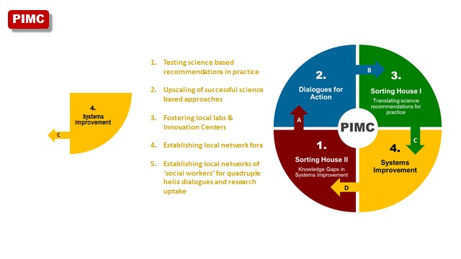RE-Systems Improvement

Figure 9: PIMC Segment 4 | Systems Improvement

This segment of the PIMC1 could be designed e.g. as a two or three years process for testing science based recommendations in practice in the RE-System (RE-System are all interacting actors in the field of RE according to the quadruple helix model: academia, businesses, policy makers and civil society) and for upscaling of successful science based approaches.
The CoSe will have to continue with the implementation and maintenance of the communication concept of Sorting House I in this segment for ensuring, that all actors who should be addressed with the science recommendations will be reached. The launching of urban or rural laboratories for testing research based solutions and e.g. building innovation funds could be supported by the RE-network via the CoSe.
Furthermore the CoSe will have to secure feedback loops with the innovators and institutions for innovation as a part of the PIMC1 M&E (programme level) process. This would allow identifying future research and innovation demand which would feed into the activities in segment 1 of the PIMC2, the Sorting House II in preparation of the future PIMC(s).

✦ Pre-identified LEAP-RE/ RE-Alliance activities:
- Research demand for future research will be identified with the PIMC1 M&E tools, which will feed in particular into Sorting House II that will monitor and evaluate the ongoing research and innovation activities
- The CoSe could support the RE-network in the following fields of activities:
 Linking research with the launch of urban or rural ‘laboratories’ (labs) as regular institutions to
test solutions and develop innovation funds that are fuelling rural labs by the CoSe. LEAP-RE

funded research and the RE-network itself (built by LEAP-RE) could be linked in doing so to other
‘external’ activities of actors associated to LEAP-RE or non-LEAP-RE-associated activities.
 Budgets for projects should be earmarked to fund credits to finance small businesses who work with the research based recommendations. The regular inclusion of investment banks into the PIMC1 could be considered. Options to use these funds to set up a revolving fund could be examined to initiate and ensure sustainable processes.
 Upscaling successful research based on the M&E of the rural labs output by modelling of upscaling at both local and regional level in cooperation with selected funding organizations operating in rural and urban communities’ development.
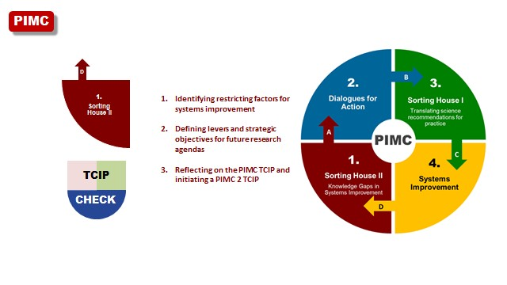 Integrating research activities in value chain strategies and designing schemes to plan upscaling and leverage.

A new PIMC | Sorting House II | Knowledge Gaps in Systems Improvement

Figure 10: PIMC 2 Segment 1 | Sorting House II

In this segment, the first of PIMC2, the restricting factors for systems improvement should be identified and analysed based on the output of the programme’s M&E process. Including a second reflection about the TCIP1 in PIMC1, levers and strategic objectives for future research and capacity building agendas should be developed in Sorting House II. The process of Sorting House II might take half a year and the output will be the preparations for PIMC2 and could include already a first draft of TCIP2 and the formation of a new PIMC2 consortium.

✦ Pre-identified LEAP-RE/RE-Alliance activities:
- M&E report PIMC1 research and innovation activities as well as ‘external’ inputs
- Conducting gap analysis and advising RE-Alliances
- Identification of factors which require additional research through overarching studies on research outputs and outcomes and approaches that were provided
- Systematic planning of up- and out-scaling in R&I projects

- Reflection of the PIMC1 TCIP1 and drafting a TCIP2 and PIMC2
- Contributing to a PIMC2 kick-off conference by
  - drafting TCIP2
  - drafting solutions towards RE-system improvement, in particular the definition of practical recommendations / levers for governance and the RE-system, including discussion of externalities and SDGs
  - 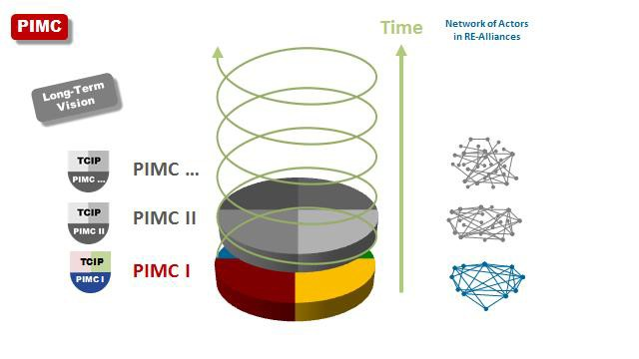the improvement of the PIMC model and the maintenance of knowledge management and communication infrastructures

Figure 11: PIMC as a long-term model for RE-Alliances

LEAP-RE, or the RE-Alliance emerged from LEAP-RE, will close the PIMC1 with the output of Sorting House II and several R&I activities. The PIMC might take 7 or more years for one full cycle.
Further PIMCs are then expected to follow, starting again with the output of the reflections on TCIP1 and PIMC2 and a new TCIP2 and PIMC2 in Sorting House II. A self-sustainable management and coordination infrastructure after LEAP-RE and maintained by the RE-Alliance for future PIMCs will then be available and will be developed further according to the needs in PIMC2 and other following PIMCs in the future.
A PIMC is not for a closed group of actors like the LEAP-RE consortium during the programme’s period. It includes activities that might have been initiated already by different actors who are relevant in all four segments of the PIMC model. Since synergies of envisaged and ongoing activities have rarely been identified and the actors have not coordinated their resources, agendas, nor knowledge management and communication tools and methods, the PIMC has been developed to serve as a reference point for collaboration of different actors also beyond LEAP-RE in coming RE-Alliances. The coordination of the four segments of the PIMC would therefore become the pivotal point for closer collaboration.
The PIMC model is a pilot that has been developed for addressing the long-term perspective for collaboration in the field of RE. It is at the same time part of a concerted action in line with the other two H2020 LEAP-projects in the field of food systems (LEAP-Agri & LEAP4FNSSA).

All LEAP-Projects are addressing roadmaps of the AU-EU-HLPD (one on Food and Nutrition Security and Sustainable Agriculture and the other on Climate Change and Sustainable Energies) and in all LEAP- projects is a big overlap of funding institutions but the other actors like researchers and from the private sector are different because of the different thematic fields.
Therefore, once all actors and programmes refer in their activities to the PIMC model, resources could be saved by building activities in future PIMCs on the developed management and coordination infrastructure of the CoSe, like modules, methods and technologies and in particular for knowledge management and communication.

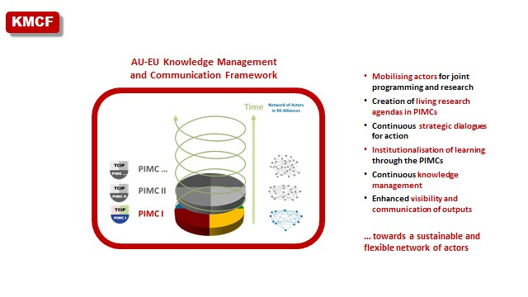Knowledge Management and Communication Framework

Figure 12: AU-EU Knowledge Management and Communication Framework (KMCF)

An AU-EU Knowledge Management and Communication Framework (KMCF) is a coordinated combination of knowledge management and communication methods, technologies and networks that exist already, or which are developed and applied in a PIMC.
The KMCF will be utilized to fulfil specific goals of the LEAP-RE programme and activities of the RE- Alliances after LEAP-RE. These goals include: a) ensuring the continuous and flexible mobilisation of the network of actors in Dialogues for Action towards joint programming and research, b) fostering the creation of need-oriented research and capacity building agendas, c) institutionalising learning, and d) a continuous inclusive knowledge management for an enhanced visibility, dissemination and communication of research outputs.
LEAP-RE will foster synergies and agreements towards a closer and sustainable collaboration in knowledge management and communication. E.g. managers of existing data bases will be motivated to collaborate closer and identify gaps in their collaboration as well as for the impact envisaged with the maintenance of a network of data bases and communication activities. A self-sustaining coordination infrastructure as an element of the PIMC’s management and coordination infrastructure beyond LEAP-RE is envisaged.

KMCF elements in the PIMC1 on the operational level

PIMC1 Segment 1: Sorting House II
  - Reflection process with stakeholders (workshops, consultations and M&E outputs)
  - Draft TCIP1 and PIMC1
  - Organising the first PIMC1 funders meeting (by the CoSe)

PIMC1 Segment 2: Dialogues for Action
  - Physical and virtual meetings of actors for network building and the development of agendas and pathways as well as for funding decisions for R&I projects (focussed roundtables, workshops, consultations)
  - Initiating networks of:
    - Funders
    - Researchers
    - Entrepreneurs/innovators
    - Decision makers
✦ maintaining the networks with adequate social media principles, an address data base where necessary and regular face-to-face meeting
  - Communication concepts for research uptake on the project and programme level as an element of funding schemes for R&I
  - Creating and a data base for research results
  - Creating a network of data base managers for establishing interfaces where needed and fostering collaboration
  - Initiating a CoSe with central functions and ‘infrastructure’ like data bases, communication channels and media as well as for initiating and maintaining network activities and the management of the Sorting Houses I and II.

PIMC1 Segment 3: Sorting House I
  - Reformatted science based recommendations for action and dialogues with target groups
  - Media for the communication with target groups such as videos, radio programmes, schools and training institutions, participatory research etc. addressing producers as well as decision makers in the RE-Alliance(s)

PIMC1 Segment 4: System Improvement
  - Fostering of local labs and innovation centers
  - Establishing local revolving funds for R&I
  - Local network fora about RE
  - Networks of ‘social worker’ for research uptake and capacity building
  - Feedback loops as an element of the M&E system organised by the CoSe

✦ PRE-LEAP-RE KMCF activities:
- Round tables and workshops with potential consortium partners and associated partners in LEAP-RE
- Development of M&E instruments (methods and technologies)
- Conceptualising the CoSe

✦ Pre-identified LEAP-RE KMCF activities:
- Regular face-to-face and virtual meetings and workshops of actor groups like governments and ministries, funders, entrepreneurs, innovation hubs, researchers, data base managers
- Development of communication elements :
- Conceptualising and initiating regular face-to-face and virtual meetings and workshops of actor groups like governments and ministries, funders, entrepreneurs, innovation hubs, researchers, data base managers
- A data base or interfaces to existing data bases for the long-term establishment of an infrastructure for displaying LEAP-RE research output and that of following PIMCs.

- A communication concept and infrastructure for the Sorting Houses I & II including regular meetings and workshops.
- A communication concept as a part of the M&C infrastructure of LEAP-RE towards a long-term process of future PIMCs
- An communication infrastructure for the Sorting Houses I & II
- M&E of LEAP-RE research activities
- Output management of LEAP-RE research activities
- Preparing the start of PIMC2 with Sorting House II output and inviting to Dialogue for Action 2 in PIMC2 with a kick-off conference which allows the intra- and inter-action of the actor’s groups.

Issues like open source philosophy and Intellectual Property Rights (IPR) will have to be addressed (see the #2 BP Funding & Private Sector).

Coordinating Secretariat Concept
The coordination in a PIMC and in following PIMCs in an AU-EU KMCF requires an ‘institution’ that will fulfil the following needs:
- Designing and implementation of Dialogues for Action
  - of funders, managers of data platforms, research institutions, entrepreneurs, decision makers towards R&I (individual and common meetings on different geographical level)
  - meetings addressing or with HLPD (Bureau)
  - organization of general assemblies
- Communication concept for the network on RE
  - Website
  - Linkages to data bases on RE
  - Links to innovation systems
  - Collecting reports of research projects funded by EJP-LEAP-RE
  - Communication with actors (social media, newsletter, events, organizing the representation of EJP-LEAP-RE during conferences, workshops, etc., contributions to journals)
  - Other publications about EJP-LEAP-RE
  - Collecting reports of Sorting House I & II including the maintenance of impact assessment
- Application of the TCIP approach as a reflection process and instrument of one PIMC and as intermediation for following PIMCs in the future.
- Call management
- Joint Programme (JP) budget management
- Reporting to
  - EJP-LEAP-RE consortium
  - AU-EU HLPD (Bureau)
  - EC during EJP-LEAP-RE

The Coordinating Secretariat (CoSe) is a managing office which will be coordinated by an African and an European institution as co-coordinators and supported by an executive group. On a periodical basis, which could means e.g. after one PIMC, both institutions will hand over the responsibility to a following ‘African-European-Tandem’ as co-coordinators. A policy board in close collaboration with the general assembly and an advisory board for independent advise as well as an an ethical board will be managed by the CoSe.
The sustainable funding of a CoSe has to be developed during the EJP-LEAP-RE.

The Belmont Forum, e.g., is working with a membership fee to fulfill its management and coordination needs, which perhaps could be an inspiring model for LEAP-RE after EJP-LEAP-RE.

Glossary

2iE | Fondation 2iE Association, Burkina Faso
ACU | Association of Commonwealth Universities, UK
AESG | Africa Energy Services Group Ltd., Rwanda
AMGA | Annotated Model Grant Agreement
ANER | Agence Nationale pur les Energies Renouvable, Sénégal
ANME | Agence Tunisienne de la Maitrise de l'Energie; Tunis
AU | African Union
BLE | German Federal Office for Agriculture and Food | Bundesanstalt für Landwirtschaft und Ernährung
CA | Consortium Agreement
CCSE | Climate Change and Sustainable Energy
CEA | Commissariat à l'énergie atomique et aux énergies alternatives, France
CoI | Confirmation of Interest (of those who sent a letter of support before the GA)
CSIR | Council for Scientific and Industrial Research, South Africa
CSP | Concentrated Solar Plant
DEDEAT | Economic Development, Environmental Affairs and Tourism, South Africa
DLR | German Aerospace Center
DLR-PT | German Aerospace Center - Project Management Agency
DoA | Description of Action
DoW | Description of Work
DST | Department of Science and Technology, South Africa
ECCP | Electronic Content Collaboration Platform , PRE-LEAP-RE partners only
EERA | European Energy Research Alliance
EJP | European Joint Programming
EoI | Expression of Interest
EU | European Union
FCT | Fundação para a Ciência e a Tecnologia, Portugal
FNSSA | Food and Nutrition Security and Sustainable Agriculture
GA | Grant Agreement; also AMAGA
GC | Group of Contributors (Ministries, funding agencies, public and private research institutions and actors from the private sector like e.g.entrepreneurs)
HLPD | Hich Level Policy Dialogue
IE | KIC Innoenergy SE, Belgium
IPR | Intellectual Property Rights
JYU | Jyväskylä Yliopisto/University of Jyväskylä, Finland
KINNO | Knowledge & Innovation Consultanta Symvouleftiki Monoprosopi Epe, Greece
KMCF | Knowledge Management and Communication Framework
LEAP | Long-term Joint EU-AU Research and Innovation Partnership
LEAP-Agri | Long-term Joint EU-AU Research and Innovation Partnership on FNSSA (ERA-Net  Cofund)
LEAP-RE | Long-term Joint EU-AU Research and Innovation Partnership on Renewable  Energy (RIA)
LGI | LGI Consulting, France
MESRS | Ministry of Higher Education and Scientific Research, Algeria
MI | Mission Innovation
NRF | National Research Foundation, South Africa
NWO | Netherlands Organisation for Scientific Research

OA | Open Access
PAUWES | Pan-African University of Water and Energy Services
PIMC | Programme and Innovation Management Cycle
POLIMI | Politecnico di Milano, Italy
PRE-LEAP-RE | PREparing for a Long-term Joint EU-AU Research and Innovation Partnership on Renewable Energy (CSA)
RD&D | Research, Development and Demonstration
RE | Renweable Energy
REA | Research Executive Agency under the power delegated by the EC
RES | Renewable Energy Sources
SG | Stakeholder Group
SOM | Senior Official Meeting
SU | Strathmore University, Kenya
WASCAL | West African Science Service Center on Climate Change and Adapted Land Use

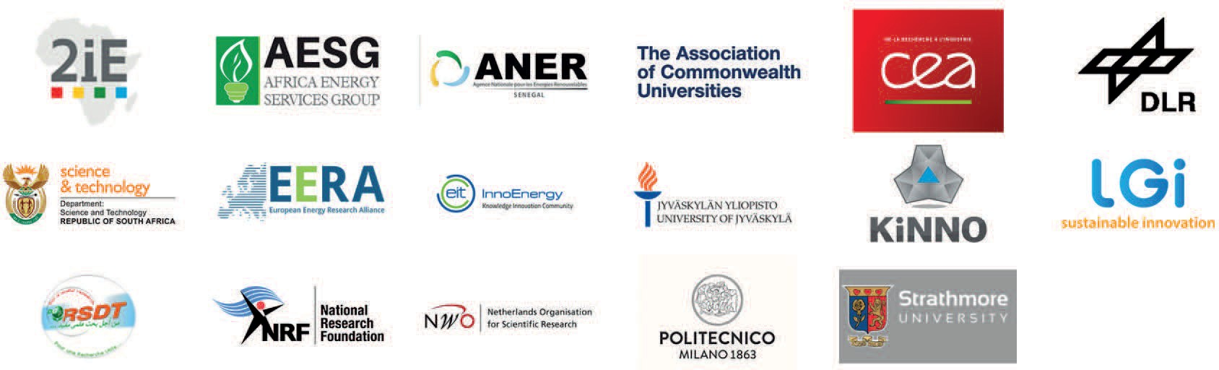

PROJECT PARTNERS

The PRE-LEAP-RE project has received funding from the European Union’s Horizon 2020 Research and Innovation Program under Grant Agreement 815264.

PRE-LEAP-RE © 2019

